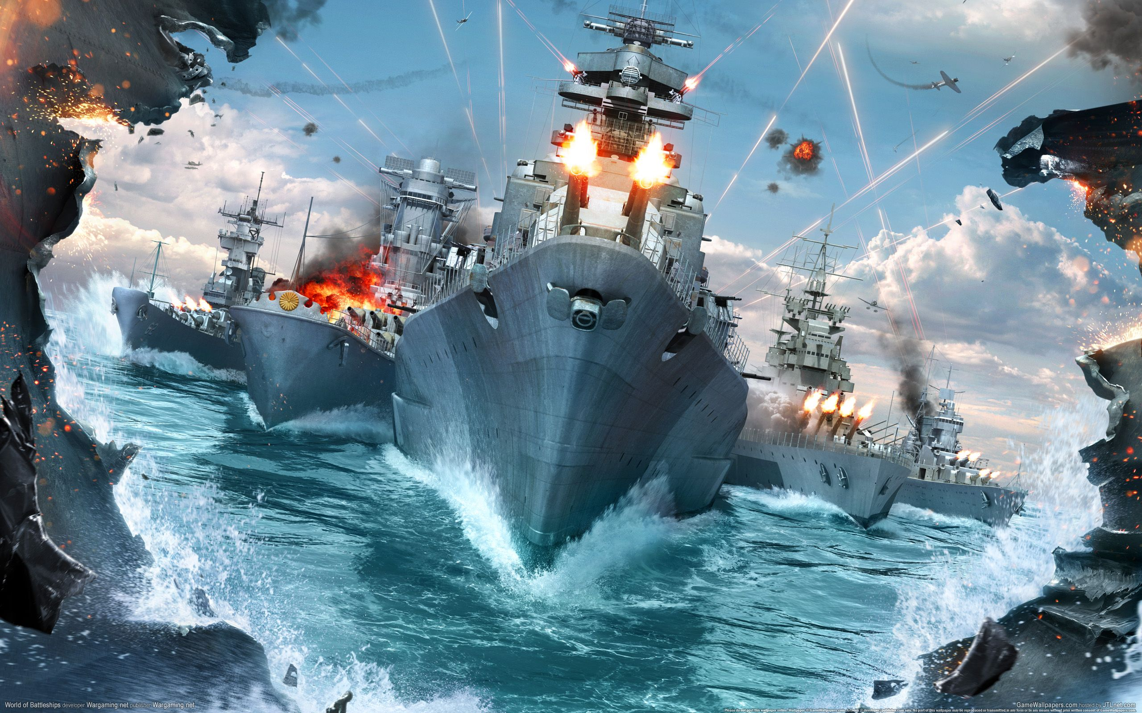James Diefenbach

Software Design and Development Y12

Assessment 2: Strategy Game [Battleship]

Phase 1 and 2:

Understanding and defining the problem

Planning and design

Table of Contents

Defining the problem 3

Design specifications 5

Modelling representations of the system 8

Communication issues considered 11

Module Descriptions and IPO Charts 19

Variable Scope, Structure and Parameters 25

Module Algorithm Development 26

Screen Designs 38

Phase 1: Understanding and defining the problem

# Defining the problem

**The problem provided by the client is to create a turn-based strategy game, specifically Battleship, and to be graphical by nature.**

Detailed description:

Extrapolating, the details of the game and hence the project is as follows:

* Players place ships on a 10x10 grid taking up 5,4,3 (twice) or 2 tiles
  + Horizontally or vertically (i.e. not diagonally)
  + Not overlapping or outside of the board
* Players take turns firing
  + Each player can only see their own ships on their own grid displaying their ship locations alongside the opponents hits and misses, yet they have a second grid they can see representing the opponent’s grid. This grid is only ever filled with that players hits and misses.
  + Player chooses a grid location (using algebraic notation ‘A1’ - ‘J10’)
  + The opposing player checks that location on their own board for any of their ships
  + If the location lands on a ship the opponent returns “hit” and both players place a red peg on that location on their respective grids
  + If the location doesn’t land on a ship the opponent returns “miss” and both players place white pegs on that location
* When all (5,4 etc.) tiles of a ship are ‘hit’, the player whose ship has been hit in all locations says “hit and sunk”
* Whichever player has all 5 of their battleships sunk loses

Needs:

* Moves and all interaction to be made via mouse / graphical system
* Scores to be saved (and assigned to each user)
  + Login using username and password
  + Sign up: add username and password to system
  + Leaderboard and statistics display
* Single player mode (AI-like system)
* Turn-based system (including intermediary screen to deter screen cheating)
* 10x10 grid system which can display hits/misses and ships, as well as be interacted with for both ship placement and target system
* Graphical display of 10x10 grids as seen by one player at a time, and graphical display of hit and miss pegs on both grids.
* Graphical display of the 5 different ship types on the grid
* Clear, succinct communication of valid or invalid placements / targets
* Clear communication of events i.e. hit, sink, win

Boundaries:

* Limited to a single computer (as a demonstration before online interactivity) and as such a single screen and mouse
  + This creates a practical limit on the number of elements (including player grids) on one screen
* One hit per turn and 5 ships to be placed vertically or horizontally
  + One aircraft carrier (5 tiles), one battleship / destroyer (4 tiles), one cruiser(3 tiles), one submarine (3 tiles), one patrol boat (2 tiles)
* All inputs (with the exception of inputting username and password) must be done via mouse movement
* The program as a whole should be continuous and the least intrusive on the user’s system so a reasonable boundary of the game is that it all lies within one form.

Objectives:

* Create a fun, entertaining and intuitive strategy game
  + A single player mode
  + Original two-player mode
  + Multi-player mode which can include several players including AI
* Create a competitive and fair game
  + Scoreboard / leader board / Ranking system (ELO)
  + Fair turns and equal pieces etc.
  + Upholding rules such as no overlapping ships or diagonally placed ships (incl. disadvantageous exploits such as skipping a turn or hitting the same location twice)
  + Saving and returning events such as a hit, miss, sink or win
  + Hide the opponent’s grid and an intermediary screen in-between different players’ turns
  + Describing to players where and how they hit / were hit, including which ship was sunk and how many ships players have left alive.

Requirements of the problem:

* Moves and all interaction to be made via mouse / graphical system
  + User Interface
* Users to sign in and Scores to be saved (and assigned to each user), including displaying of users’ statistics
  + User Registration Module
* Attack / target system with hit,miss,sink, defeat and win events
  + Attacking Module
* Turn-based system, placement of ships and intermediary screens between players
  + Turn-layout Module

# Design specifications

Data dictionary

*Note that ‘~’ denotes a variable length, representing the number of players for most arrays, with the exception of Users[~] which extends to the size of total users stored in the BUD file.*

User registration module

|  |  |  |  |  |  |  |  |
| --- | --- | --- | --- | --- | --- | --- | --- |
| Variable name | | Data type | Data format | Field size | Description | Example | Validation |
| Players [~] | | Fixed Length String | XX… | 16 | Storage of each player’s username | BattleshipPlayer1  …  BattleshipPlayer4 | Same as User.user |
| User [~] | **User** | Fixed Length String | XX… | 16 | As obtained from a text file, represents the user’s unique name | BattleshipPlayer1 | Inputs are validated beforehand (more than 8 char, 1 integer, must be unique) |
| **Pass** | Fixed Length String | XX.. | 16 | Represent’s the user’s password | P@ssward | “ |
| **Wins** | Integer | NNN… | 256 | The user’s wins | 8 | None |
| **Loss score** | Integer | NNN… | 256 | An arbitrary score representing the number of players the player has lost to, (for multiplayer mode of x players, if the user dies first he will gain a loss score equal to the number of players left alive after he dies) | 15 | None |
| **Hits** | Integer | NNN… | 256 | The number of ship tiles the player has hit | 205 | None |
| **Misses** | Integer | NNN… | 256 | The number of non-ship tiles the player has hit | 450 | None |
| **Accuracy** | Float | NNN… | 256 | Arbitrary score representing the total hits divided by the total times fired | 31.019 | Total times fired can’t be zero, if so replace accuracy by 0 |
| Input User | | Fixed Length String | XX.. | 16 | Login or sign in value of username | BattleshipPlayer1 | Between 4 and 8 characters long  Not null |
| Input Pass | | Fixed Length String | XX… | 16 | Login or sign in value of password | Pa55w0rd | Between 4 and 8 characters long  Have at least one number  Not null |

Attacking Module

|  |  |  |  |  |  |  |
| --- | --- | --- | --- | --- | --- | --- |
| Variable name | Data type | Data format | Field size | Description | Example | Validation |
| Hits [10, 10, ~] | Nullable Boolean | Null/true/false | 100x1 | Set to true for hit, false for miss or null for when the grid has not been shot at yet | True  False  Null | N/A |
| HitWeight[10,10,~] | Float | XXX.XXXX… |  | The AI’s calculation of how likely a ship is to be on that grid position | 0.11000  0.0000  0.8800 | N/A |
| Dead(~,6) | Boolean | True / false | 4x5x1 | Holds the Boolean representing whether the players 1st (aircraft) ship is alive or 2nd (battleship) is alive etc. for each player as well as whether the player is alive or not | False  False  True  True  True  False | N/A |

Turn-Layout Module

|  |  |  |  |  |  |  |
| --- | --- | --- | --- | --- | --- | --- |
| Variable name | Data type | Data format | Field size | Description | Example | Validation |
| CurrentPlayer | Integer | N | 1 | Indicates which player in the player[] array is currently taking their turn | 1  2  3  4 | Not null |
| targetPlayer | Integer | N | 1 | Indicates which player is currently targeted / attack (to be displayed on the top grid) | 1  2  3  4 | Not null |
| Ships [10,10,~] | String | XX | 100x2 | Has a specific naming convention indicating:   * type of ship * tile number of ship * orientation * condition | OOOO  B1HO  B2HO  B3HX  P1VS  P2VS  A5HX | N/A |

Interface design specifications

The user interface (UI) has to simultaneously provide output and intuitively indicate where to input data to / from the user. As outlined in the requirements and objective of the problem the UI should:

* Display 10x10 grids for each player with either graphical representations of the ships or hits / misses which will:
  + Allow the placement and rearrangement of ships
  + Receive input of the player’s targeted square
  + Update the states or hit/miss states of squares dynamically
* Easily work around screen cheating and the transition between player’s turns
* Allow the registration and de-registration of users including:
  + Artifical players
  + Players with no account, who wish to play as guests
  + Players with no account, who wish to sign up
  + Players with pre-existing accounts

However, as identified by the boundaries of the problem the battleship game is limited to a single computer / screen as well as taking all inputs (except for account name / password) via the mouse.

The decided methods for the UI requriements are as follows:

10x10 grid(s):

A table layout panel containing 10 rows and 10 columns

* Each cell will contain a picture box containing the appropriate graphics
* The picture boxes will also have events for user’s clicks and other interactions
* (Multi player) a numeric up and down box will be used to change the displayed enemy player’s grid.

*To clarify, by iterating through the values in the numeric up and down the panel that displays the only enemy’s grid for two player will change through the different enemies for multi-player.*

Transition system:

* Will output to the user who the next player is
* Will also output hit/miss/sink
* Will display a simplified grid showing the hits and misses on the target player through a tablelayoutpanel of buttons
* Allow the next player to click a button to start their turn

Registration system:

* Textboxes for username and password fields
* Buttons for login or registering new users as well as un-registering users
* Picture boxes representing either AI, Guests (1-3) which will register the selected player as the aforementioned special player type
* Numeric up and down box for selecting players already registered or new players to register

*For clarification, the concept for ‘players’ is the index 1 – 4 that is assigned to a user / guest or AI, so the num-up-and-down selects the current index 1-4 including already assigned ‘players’ for de-registration or empty ‘players’ to be assigned.*

# Modelling representations of the system

Data flow diagram

Attacking Module

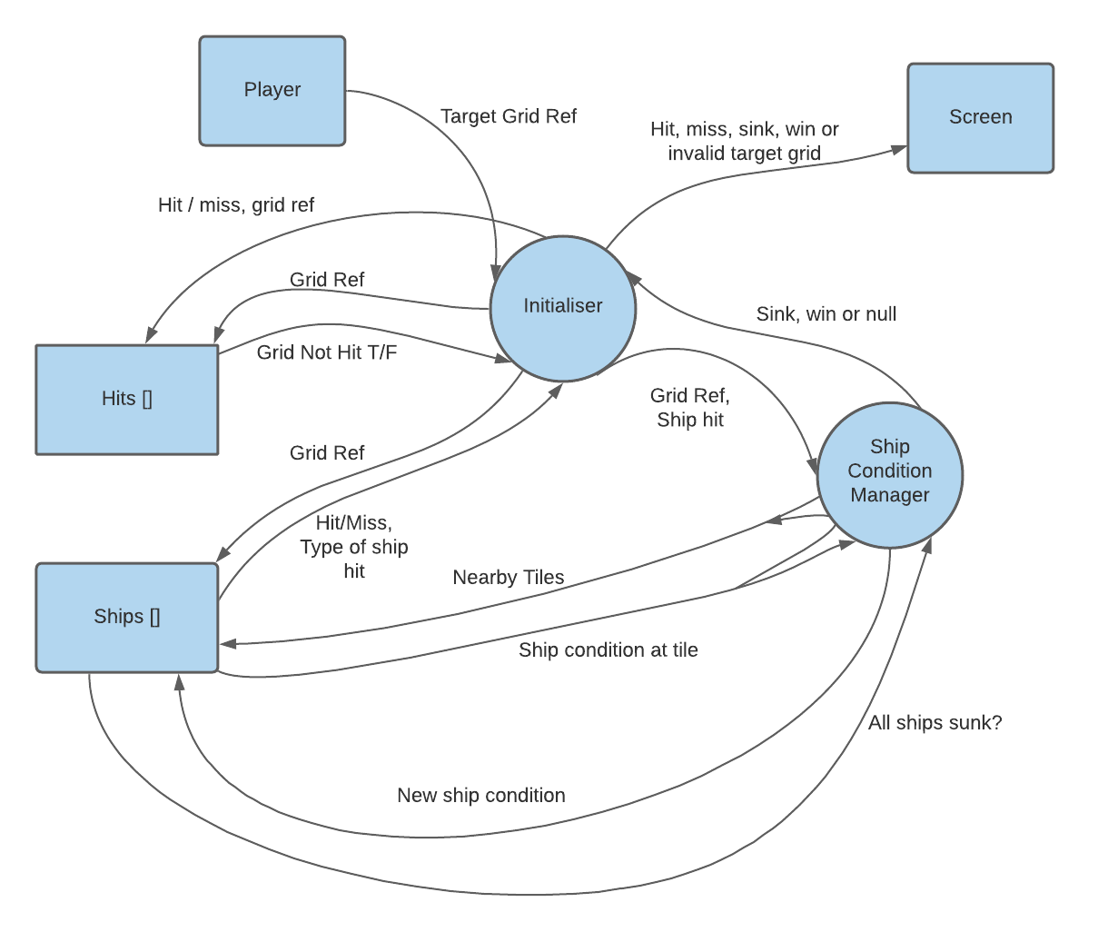

User Registration Module



Layout Module

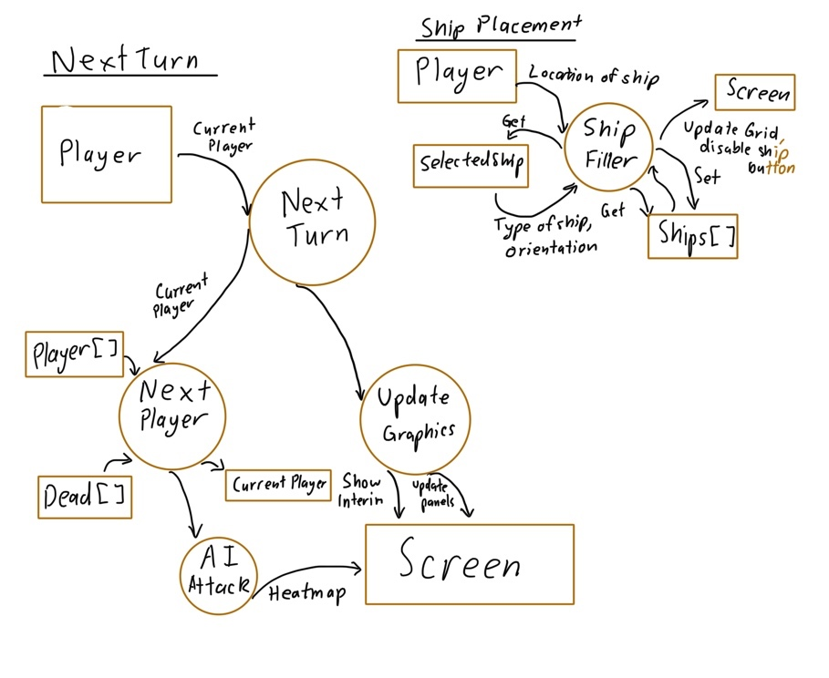

Structure Chart

# Communication issues considered

User / client communication systems

*There are many things to be considered when creating a virtual battleship game. More modes and variations from the original game are available, new features such as customising pieces, names and rating systems are also now feasible.*

*Problems also arise such as the method of displaying and retrieving user-input while staying faithful to the original Battleship, especially creating a style of grid and input method that appeals to user’s aesthetic and functional needs. Most importantly, it is necessary that Users understand the functions and transitions of the Game, in addition to the events and changes that occur between changes of players.*

The first thing to be considered was what overall style the game should be, and what level of simplified graphics is appropriate.

The response from the user survey was 2/3 towards a ‘sleek, modern and minimalist style’ as opposed to two other options, discussed further on. The inspiration, was communicated as from chess.com initially however, a **vector based** compromise is both minimalist while easily recognisable and identifiable as an aircraft carrier or any other ship type.

Another novel idea was a multiple player mode, with an upper boundary of 4 players in consideration with complexity and the layout of the screen. The multi-player grid would be additively expanded from the original two player grid, adding one or two more grids to form a 2x2 grid of player’s grids. This appearance would either rotate every single turn, such that the current player will remain in the bottom left every turn, or always contain the same players without rotating. Either rotation is difficult to understand, such is the cause of the limit of 4 players and exponential complexity of battleship.

The Two Player Grid Appearance

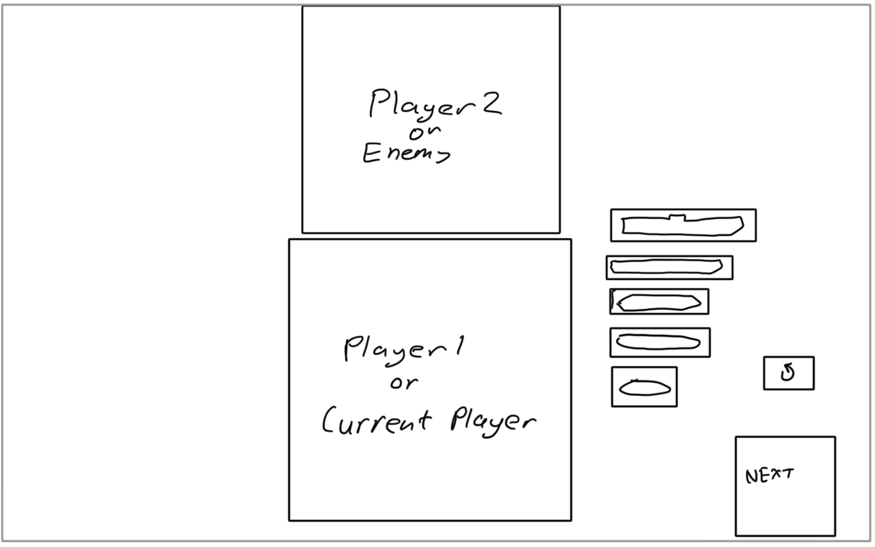

This basic two player, traditional grid layout clearly communicates the enemy grid and current player grid.

The Multi-Player first concept:



However, when considering the limits of the screen for players upwards of four, a solution was conceptualised of iterating through each player’s grid rather than showing all grids at once. This would be a feasible workaround for the limits of the screen and rendering all panels at once, while also simplifying the grid arrangement and loading of the four player mode. For simplicity however, players upwards of four may be disabled or when registering upwards of four players warning the user(s) that too many players can cause a confusing game.

This new design clearly communicates the users where the current player is, who is the enemy and how to target different enemies while retaining the ability to play with more than 2 players at once.

The Final Combined Multi-Player Grid:

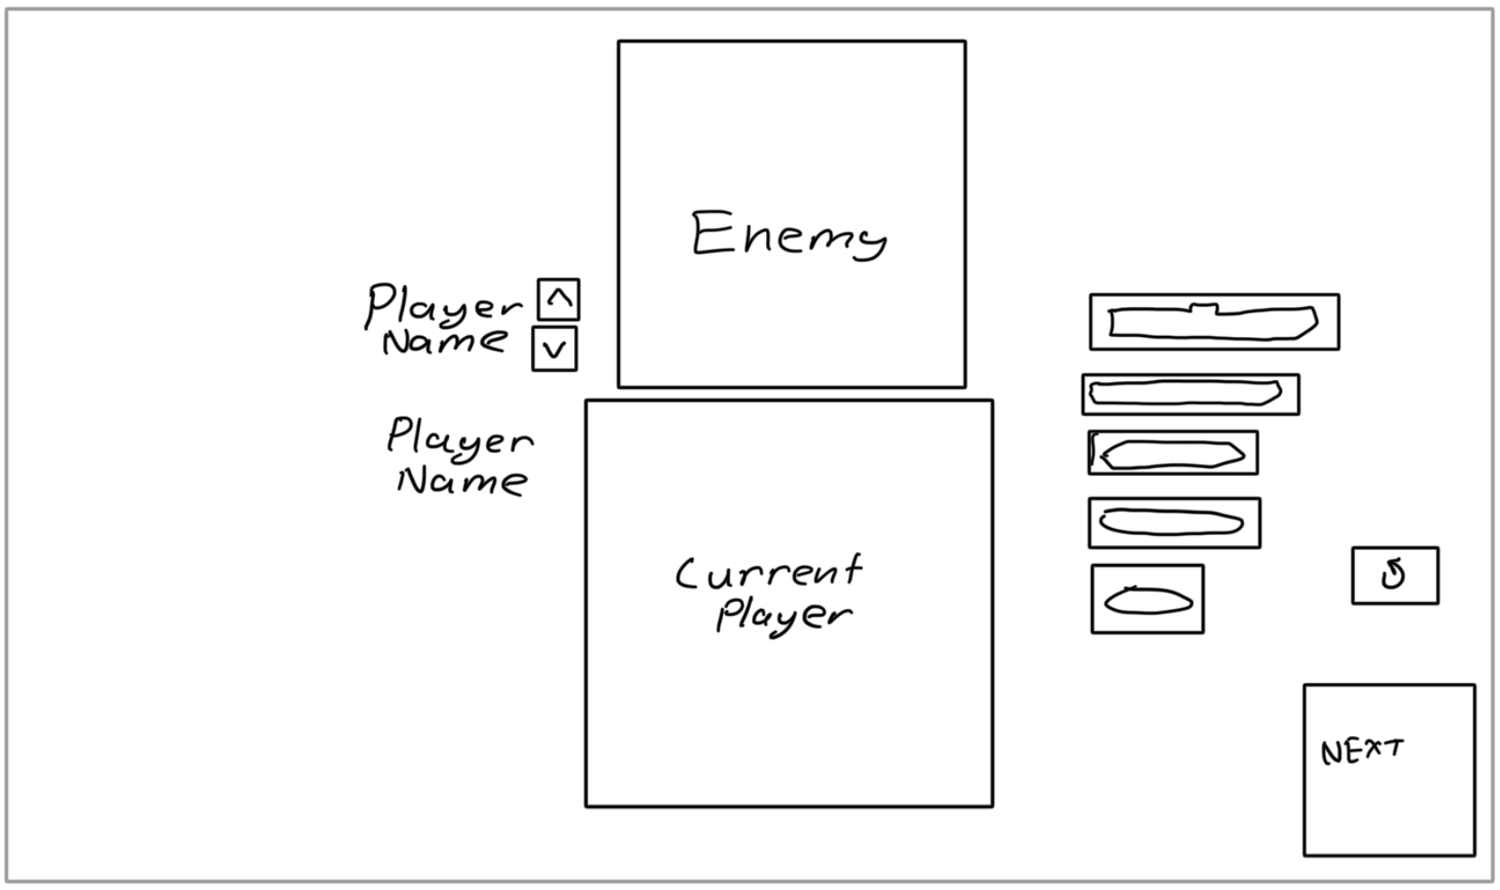

With the addition of multiple players, players must be defeated instead of a single win, meaning they can no longer be targeted, which can be confusing for users if not communicated properly. This, in addition to a history of attacks between players, can provide necessary information for larger number of players to create game permeance between players.

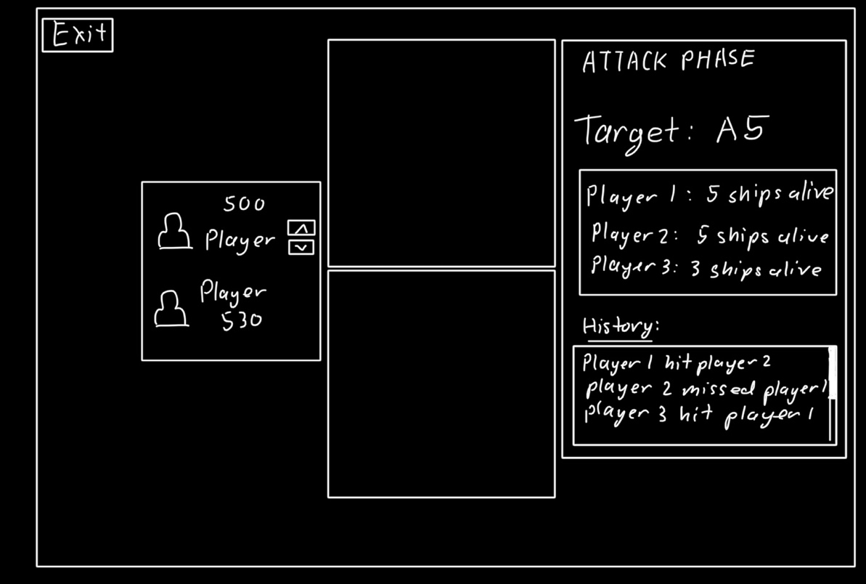

This attack phase, as well as the updated layout phase also provide information on each player’s ELO.

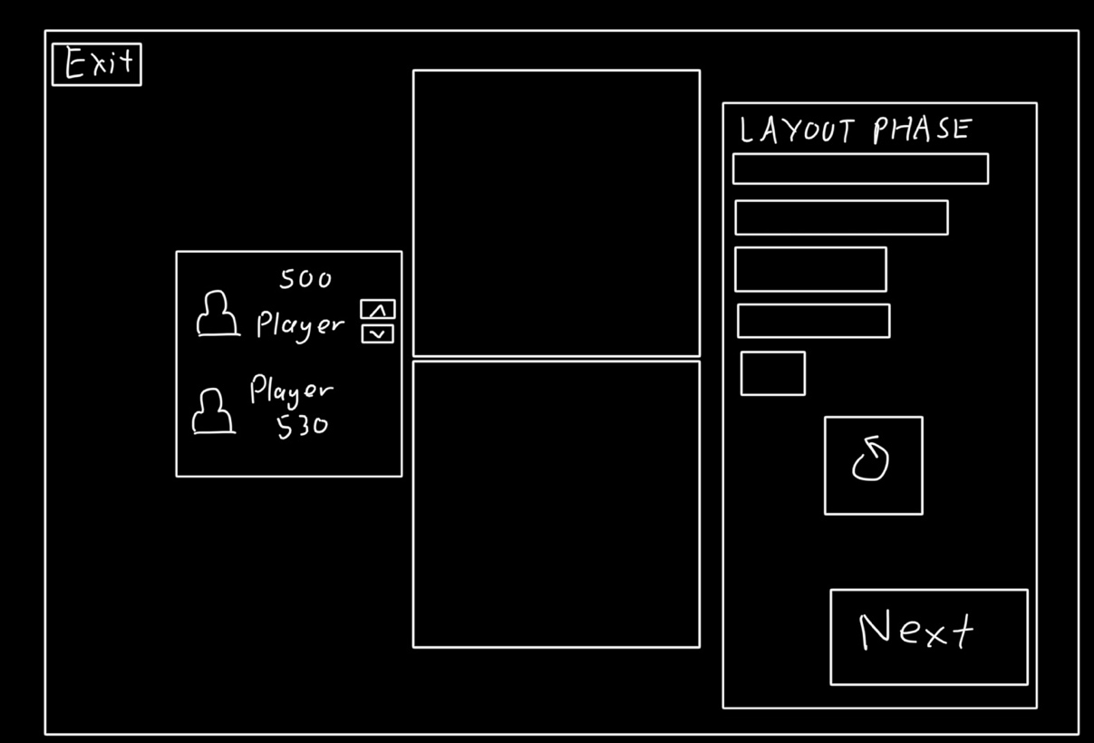

The transition scene should also provide information on what the previous attack was, in addition to the history of all attacks used in the attack phase. In summary, it will succinctly communicate the latest hit and visually where that hit was, while loading the new player’s grids in the background while visually obstructed. This grid displaying the latest hit can also be added to, to display the AI’s thinking process in attacking, simply for entertainment and interest.

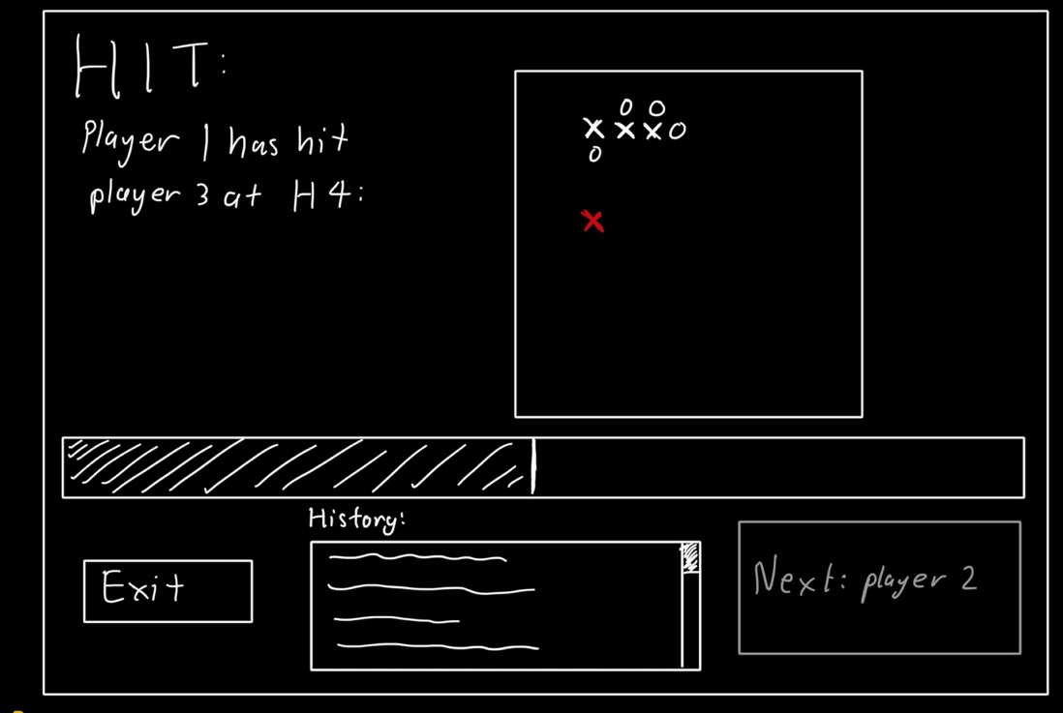

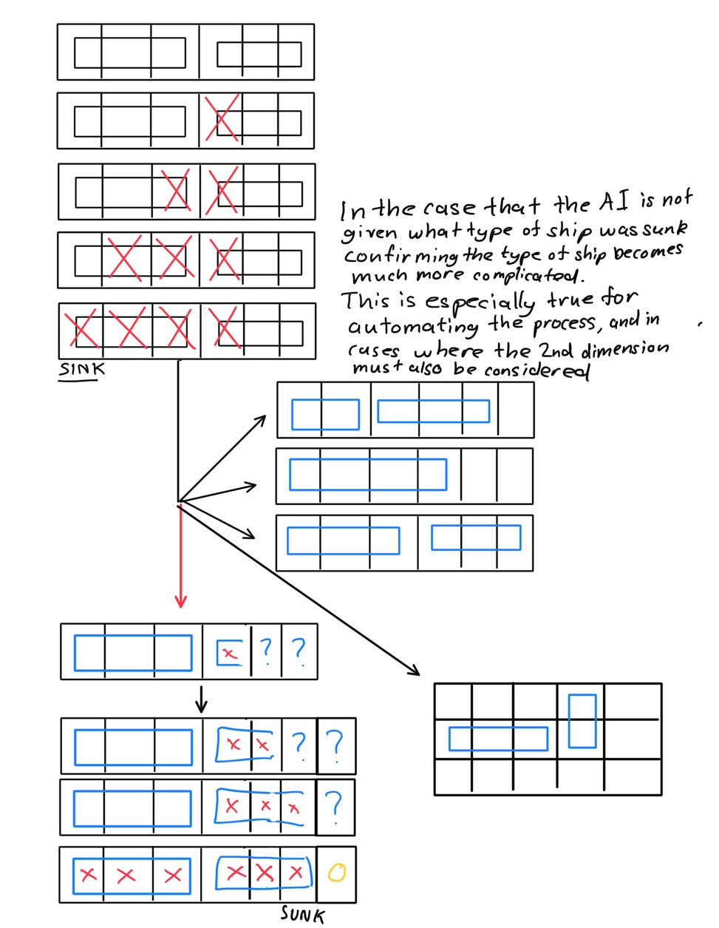One other consideration is the response to players when ships are sunk, with the options of telling the user that a ship was sunk or telling them which ship was sunk. When conceptualising the AI’s system of disregarding sunk ships to increase it’s skill / difficulty it was clear that it was best to provide information of which ship was sunk, as otherwise the AI’s own algorithms for determining which ships was sunk and where to fire would be overcomplicated especially for two dimensions:

*For example, there are several cases for the same set of 4 hits in a straight line, with the right side indicating possible cases where the type of ship sunk is unkown, and the bottom left showing the simple approach enabled by eliminating the tiles sunk.*

Create a user survey that may be used to determine the user’s needs of the system

The survey is needed to determine the user’s needs of the system, and style and design choices that must suit the audience playing the game. It can also be used simultaneously to see the opinion and feedback on new ideas possible with an online game i.e. moving ships between turns.

1. If you were playing Battleship on a shared computer: Should the player tell the other player hit/miss/sunk or should the computer provide audio / visual output for a hit/miss/sink

* Player
* Computer

1. Have you ever played Battleship online before?
2. What is your opinion on a rating / competitive system in Battleship (is there enough strategy to warrant a rating system?). And how would you feel about a scoreboard and scoring system?
3. Do you see any problems or differences in playing Battleship on one computer instead of two separate boards?
4. Out of many possible variation of Battleship that are possible using code, which of the following do you think adds the most novelty and fun to the game?

* Single Player (AI) mode with varying difficulties
* Multiplayer (3-4 and more) mode
* Powerups such as revealing a tile or moving a ship

1. On an online version of Battleship, which graphical style of user interface (buttons, ships and graphics) do you think is best suited?

* Sleek, plain straightforward much like the board game version
* Modern, animation heavy, flashing lights and urgent / immersive feel
* More historical / authentic looking ships, realistic and immersive buttons and fx

1. Which of the following features do you feel should be prioritised in the making of an online Battleship game

* Game feel, tutorial / tips and intuitive controls
* Graphics, animations and vfx and soundfx
* Fairness and bug-fixing, anti-cheat systems
* Competitive systems and score systems including leader/score board and ELO

Survey response and analysis

If you were playing Battleship on a shared computer: Should the player tell the other player hit/miss/sunk or should the computer provide audio / visual output for a hit/miss/sink

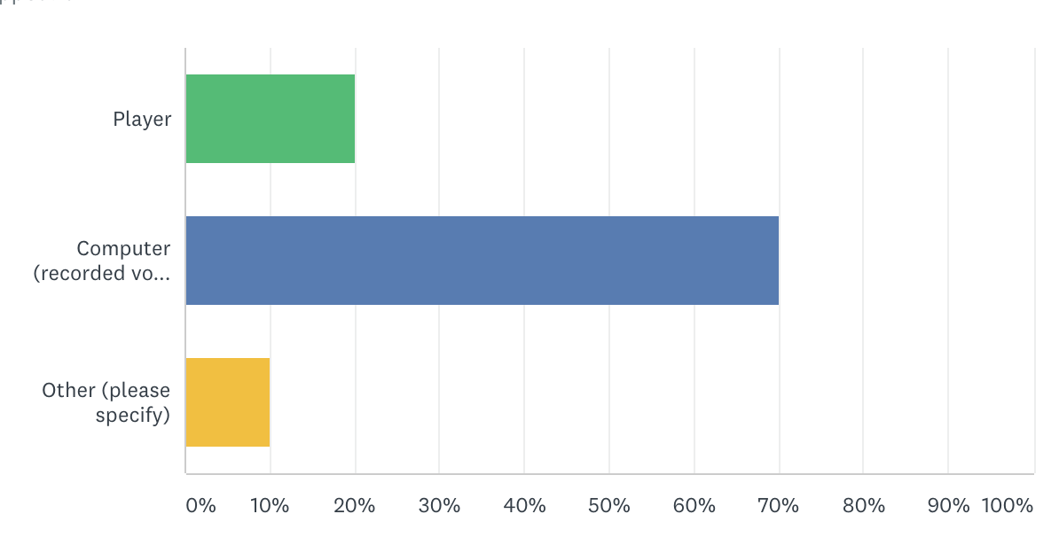

The ‘other’ responses included text and both visual and audio as options for output.

It is clear that automated voice and visual output is preferred over players, removing the ability to lie or make mistakes while also adding immersion and entertainment.

Have you ever played Battleship online before?

All responses indicated no, while some added that online battleship is a good and fun idea to experiment with. So signs point towards online Battleship being a new area for development and gameplay.

What is your opinion on a rating / competitive system in Battleship (is there enough strategy to warrant a rating system?). And how would you feel about a scoreboard and scoring system?

Most responses agreed that a rating or competitive system “seems like a cool idea” however some pointed out that Battleship is somewhat “luck based”.

Since Battleship is somewhat luck based and somewhat strategy based, a competitive system would not be totally accurate however as responses indicated – competitive environments and leader boards are a given for most modern online (board) games.

The responses brought forward the problem with measuring wins as not being very accurate as the winrate of most players will be approximately 50%. This could be worked around by measuring the ratio of hits to misses (accuracy) of players, as the targeting strategy is the major factor in determining the skill and success of a player, the accuracy could factor into the winrate for a weighted skill score.

The weighted skill score is not entirely accurate either for the same luck based arguments beforehand, so, an ELO system which naturally sorts players based on their success or loss against players of different ELO is a major possibility.

Do you see any problems or differences in playing Battleship on one computer instead of two separate boards?

All responders pointed out the issue(s) of screencheating when swapping between players, which will be overcome through the interim screen system which waits for the next player before showing their layout.

Out of many possible variation of Battleship that are possible using code, which of the following do you think adds the most novelty and fun to the game?

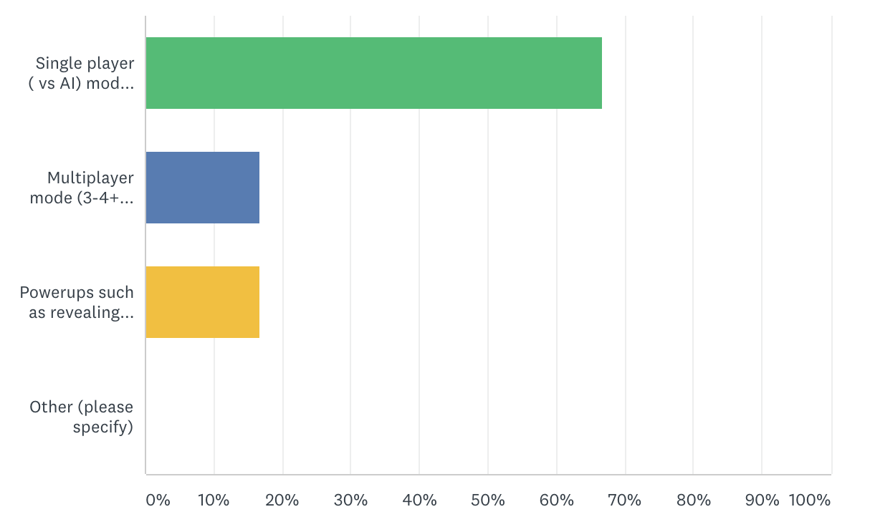

Most responders preferred single player mode over multiplayer or powerup mode, as such the order and priority of the development of these modes will be:

Singleplayer, Multiplayer, Powerup

With multiplayer and powerup mode being both goals for after completion of the main project.

On an online version of Battleship, which graphical style of user interface (buttons, ships and graphics) do you think is best suited?

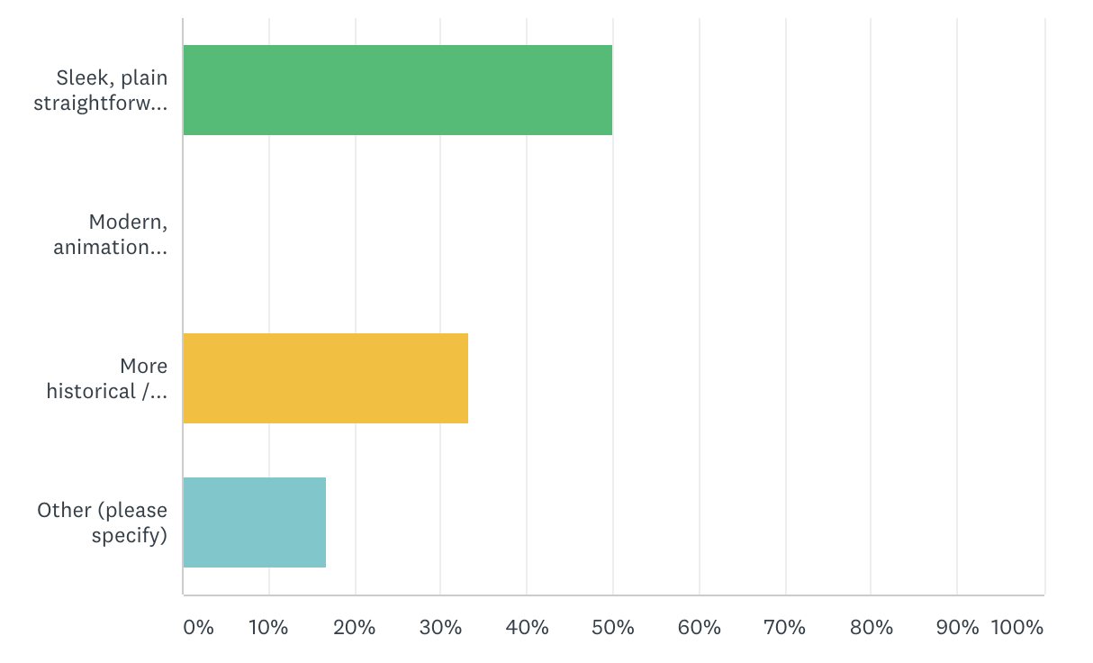

From the spread of responses, the style will be both plain while also more focused on detail and immersion.

Which of the following features do you feel should be prioritised in the making of an online Battleship game

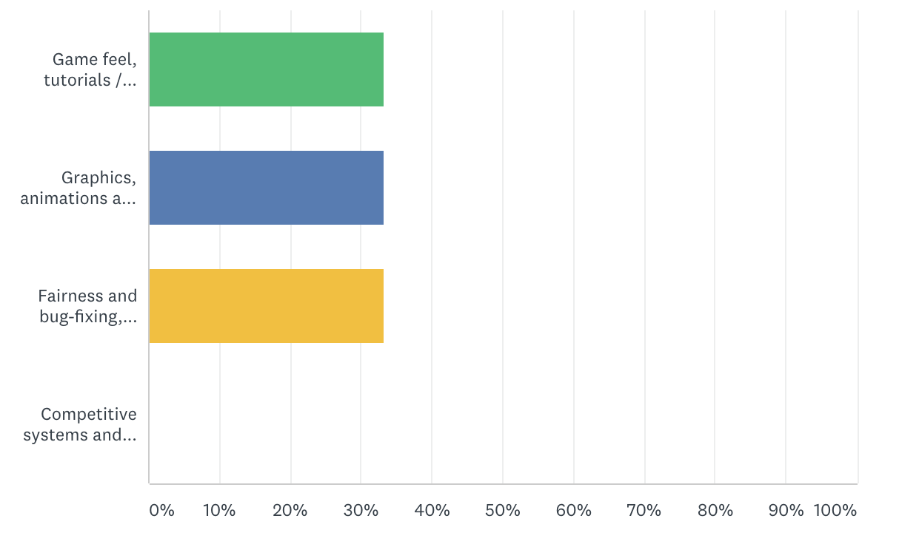

Once again, the responses are spread out quite evenly, so all three options including fairness, bug-fixing, graphics, tutorials and game-feel will be worked on and prioritised fairly evenly, while competitive systems will be implemented in their simplest forms of leaderboards, stats and possibly a basic ELO calculation.

Phase 2: Assessment of Planning and Designing the Problem

# Module Descriptions and IPO Charts

User Registration

The user registration module takes the input username and password from each player (1-4) in order. Each user is either signed up, or logged in to the battleship user database (BUD) which is stored as an external .txt file with encrypted passwords.

The retrieved / created user in the BUD will be assigned to the player[4] array respective to the current player registering, then the next player will login.

(Detailed):

*When logging in, the input username will be searched for in the BUD and then the associated encrypted password will be decrypted locally and compared to the input password. Then a Boolean is returned signifying whether both are correct or one /both is false.*

*When signing in, the input username will be searched for in the BUD (which should not already exist in the BUD) and then add the input username to the BUD. Then the input password will be encrypted and added to the BUD on the following line.*

*A Boolean is returned signifying whether the username and password were successfully added to the BUD or whether the username already exists and the signup process unsuccessful.*

*Each player will also be given the option to register as a guest from guest1 to guest4 which are normal user accounts that have no password.*

*As part of the user registration, the username and password input fields will continually validate the two variables and return descriptions of the requirements of each variable i.e. “The password requires one or more numbers”. The error output field will also return descriptions of the success or errors during the login or signup process such as:*

* *“User or password is incorrect”*
* *“User already exists, please choose a different username”*
* *“Login” / “Singup” “Successful”*

IPO Chart

|  |  |  |
| --- | --- | --- |
| Input | Process | Output |
| N/A  (Form load) | Retrieve BUD text file  Create streamReader  Extend the BUD array by 2  Assign the first Username in the BUD array to the first line read  Assign the first password to the second line read.  Loop until the streamReader returns null | Updates public User array |
| Username, Password, currentPlayer, (SignupButton.Clicked) | Search for username in BUD  Search for index of username in BUD  Check if index is not null  Compare password to encrypted password in BUD  Set Player(currentPlayer) to user index | “Successfully logged in player1 as User3”  “Username or password incorrect”  Updates public Player array |
| Username, Password, currentPlayer, (LoginButton.Clicked) | Check if username exists already in BUD  WriteToBUD(username,  password) | “Successfully signed up and logged in player2 as User4”  “User3 is already logged in as player1”  Updates BUD Text file, and BUD User array  Updates Length of all arrays dependant on the number of players (Refer to data dictionary ‘~’ variable length) |
| Username, Password  (On TextBox update) | Check username and password are not null  Check length of username  Check length of password  Check if there are numbers in password | “Username and password must both be entered”  “Username and password must both be longer than x characters”  “Username and password must be less than x characters”  “Password must contain at least x numbers” |
| Username, Password  (WriteToBUD() ) | Add username to BUD Text file  Add password to BUD Text file  Extend BUD User array by 1  Add username to BUD  Add password to BUD | Error message  “User already exists”  Updates BUD Text file  Updates BUD User array |
| currentPlayer  (On AIPlayer Selected) | Sets current index of the player array to “ArtificialPlayer” (which is impossible because it is more than 8 characters and therefore can be used as a unique identifier for AI) | Sets the current player in Player[] to “ArtificialPlayer” |

Turns and Layout (Movement)

The turn and layout module is responsible for mainly allowing each player to place their 5 ships within the grid in either horizontal or vertical orientations whilst restricting the placement of the ships to those within the bounds of the rules of the game. As such, the module takes the targeted grid (of the top-left of the ship), the orientation, and the type of ship. Then it generates the tiles that the ship takes up and checks for any overlaps either the edge of the board or other ships, and updates the array of ships and graphics or updates the graphics to indicate an invalid placement. It repeats this for each ship per player, starting with the first player.

The turn-layout module is also responsible for generating the first player by means of random number generation, and then iterating that number every turn. This also updates the controls for the attacking module, while the turn-layout module also re-arranges and re-loads the graphics of the grids to the new current player.

The layout module is also responsible for managing the graphics of each player’s grids. As well as iterating through enemies for games of more than two players.

IPO Chart

|  |  |  |
| --- | --- | --- |
| Input | Process | Output |
| Players() | Get length of Player array  Randomise from 1 to length of array  Set currentPlayer to the randomised number | Updates public currentPlayer variable |
| TargetGrid(x,y), Ship, Orientation | Check ship is not null  Compares the selected tile with the selected ship, either picking up a ship and returning any selected ship to it’s button state, or placing down the ship  Generate number of tiles ship takes up  Generate the next tile right or down depending on the orientation for each tile of the ship  (if placing)  Retrieve ShipArray(x,x,x)  Check each generated ship tile against ShipArray() to ensure the placement is not illegal otherwise it displays the fact that the placement is illegal to the player  (if valid location)  Fill each tile of the ship with a set of characters based on:   * Type of ship (A,B,C,D,P) * Index / location (1– 5) * Orientation (H / V)   Reset selected ship to null  -------  (if picking up)  Retrieve ShipArray(x,x,x)  For each ship tile that is attempted to be picked up, reset the array to empty at that point  Then set the selected ship to the type of the ship targeted to pick up | Updated ship array with naming convention  IsValidLocation as Boolean  Updates public ship var. |
| Clicked (ship) button  Selected ship variable | Gets the clicked button, and sets the current ship based upon which button was clicked  Get global selected ship variable  If there is already a ship selected, re-enable its respective button and set the selected ship respective to the button (e.g “A1VO” or “B1HO”)  Then disable the selected button | Updates public ship variable  Enables / Disables ship buttons |
| Clicked ‘Next Turn’ Button, Number of ships placed | Checks the number of ships placed against the number of total ships (5)  If all ships are placed:  Show an interim screen to prevent screen cheating  Output the next player to place ships  Update the graphics of the panels to the respective players  Update the ‘currentPlayer’ and ‘targetPlayer’ to the next player and previous player respectively  Wait for the next player to click ‘continue’ | Updates ‘targetPlayer’, ‘currentPlayer’ and graphics |
| Update Players  Current player, Targeted player | Gets the current targeted player, and update the image for each panel in the top grid to show hits and misses against the targeted player.  Gets the current (friendly) player, and updates each image in the bottom half to show misses, the ships and their states for the current player. | Updates both panels’ graphics |

Attacking Module

The attacking module takes the targeted grid from the user when the fire button is clicked, then ensures that grid has not already been fired at. Then inputs the targeted grid into the ship array, and returns the type of ship hit (if any). If hit, the stored array of hits/misses is updated to hit (or miss). The ship hit is then searched through for hits and misses, determining whether it is sunk or not.

If sunk, it updates the condition of the ship at each tile to sunk, and searches for all other ships to find if all ships are sunk. Meaning, it checks for a win and returns a win into the turn management module.

Then the highest value event is returned i.e. “miss”, “hit”, “destroyer sunk”, “win” and a graphics overlay plays either animated text or a short animation of the sinking ship.

* These events are relayed to the AI through a global char variable:
  + “M” / “H”
  + “A”,”B”,”C”,”D”,”P” (since no characters overlap with other states these imply *Ship starting with A – sunk*
  + The ‘win’ event is not applicable to the AI however on the win event the AI will output

IPO Chart

|  |  |  |
| --- | --- | --- |
| Input | Process | Output |
| TargetGrid(x,x), currentPlayer  Note: TargetGrid has a 3rd dimension associated with the player targeted however this causes no noteworthy changes to IPO | Checks the array of previous hits at the targeted grid and returns true/false depending on if the targeted grid has already been targeted  Checks the array of ship tiles to see if any ships are hit and what type of ship  Update Ships(x,x) to hit  **Trigger layout function FillShip() with paramaters indicating to check condition rather than place a ship**  Checks the condition of all tiles of the hit ship then updates condition to sunk if all tiles are hit  Checks the condition of all ships  Returns either miss,hit,sink or win (through large text on the interim page)  Update Turn-layout Module with the current player who won  Update array of hits to include hit/miss | IsValidHit as bool  Updates Hit array  Updates Ship array  Updates Turn-layout module  Creates graphic popup to display hit/miss/sink/win |
| TargetGrid(x,x),  UpdateShipCondition( ) | Get the string at Ships(x,x)  Using naming convention get the orientation, tile number, and type of ship  Using tile number and type of ship get tiles left/up and right/down  Using orientation and number of tiles to travel either side, check each tile of the ship at Ships(X,X)  Count the number of hits and if equals the number of tiles of ship then return a sink boolean  If the ship is sunk, change each tile of the ship’s condition to sunk | Returns boolean Sunk  Updates Ships() |

# Variable Scope, Structure and Parameters

|  |  |  |  |  |
| --- | --- | --- | --- | --- |
| Variable name / Parameters | Data type / structure | Scope | Description | Example |
| Players [~] | Fixed Length String | Public | Storage of each player’s username | BattleshipPlayer1  …  BattleshipPlayer4 |
| User [~] | User Structure (Ref. to data dictionary for further details) | Public | As obtained from a text file, represents the user’s unique name | BattleshipPlayer1 |
| Input User | Fixed Length String | Public | Login or sign in value of username | BattleshipPlayer1 |
| Input Pass | Fixed Length String | Public | Login or sign in value of password | Pa55w0rd |
| PlayerNum | Integer | Public | Integer representing the number of Players who are playing | 3 |

User Registration

Attacking Module

|  |  |  |  |  |
| --- | --- | --- | --- | --- |
| Variable name / Parameter | Data type / structure | Scope | Description | Example |
| Hits [10, 10, ~] | Nullable Boolean | Public | Set to true for hit, false for miss or null for when the grid has not been shot at yet | True  False  Null |
| HitWeight[10,10,~] | Float | Private  (local to AI only) | The AI’s calculation of how likely a ship is to be on that grid position | 0.11000  0.0000  0.8800 |
| Dead(~,6) | Boolean | Public | Holds the Boolean representing whether the players 1st (aircraft) ship is alive or 2nd (battleship) is alive etc. for each player as well as whether the player is alive or not | False  False  True  True  True  False |
| Message | String | Local | The message containing which player targeted which player in addition to the associated game event | Player1 hit Player2  Player2 Sunk Player1’s cruiser! |
| Sink | Boolean | Local | Boolean representing whether the latest attack has sunk one of the targeted player’s ships | True  False |
| Dead | Boolean | Local | Boolean representing whether the latest attack has destroyed the last of the targeted player’s ship and defeated them. | True  False |
| Win | Boolean | Local | Boolean representing whether the latest attack has defeated the last other remaining player, and caused the current player to win | True  False |
| AI | Boolean | Local | Boolean representing whether the AI, or the human player is currently attacking, thus indicating whether to return messages to the player or AI | True  False |

Layout Module

|  |  |  |  |  |
| --- | --- | --- | --- | --- |
| Variable name / Parameter | Data type / structure | Scope | Description | Example |
| CurrentPlayer | Integer | Public | Indicates which player in the player[] array is currently taking their turn | 1  2  3  4 |
| targetPlayer | Integer | Public | Indicates which player is currently targeted / attack (to be displayed on the top grid) | 1  2  3  4 |
| Ships [10,10,~] | String | Public | Has a specific naming convention indicating:   * type of ship * tile number of ship * orientation * condition | OOOO  B1HO  B2HO  B3HX  P1VS  P2VS  A5HX |
| selectedShip | String | Private  (Local to Layout Module) | Has the same naming convention of Ships[], indicates the first tile of the ship, from which the rest will be filled when placed | A1HO  A1VO  B1HO B1VO |
| Attackphase | Boolean | Public | Represents whether the current player is placing, or attacking | True  False |
| ValidPlayer | Boolean | Local | When changing the player, it indicates if the tested next player is valid – meaning that they are not dead or outside the bounds of the array. | True  False |
| IDPanel | Panel | Public | A reference to the ID Panel which contains the ELOs and names of each player (current and targeted) as well as the targeted index’s numeric up and down | |
| GridPanels(2) | TableLayoutPanel | Public | Reference to both the grids of picture boxes for the friendly and targeted player. | |
| UIPanel | Panel | Public | A globally accessible reference to the panel which contains the user interface for the current phase i.e. during the layout phase it will contain the ships and relevant buttons and during the attack phase it will contain the player’s number of ships and target | |
| AITurn | Boolean | Local |  | |

# Module Algorithm Development

Attacking Module

Grid Target Algorithm, for when a given grid is targeted, to return and check for hits, misses, sinks or wins.

BEGIN Function (x, as integer, y as integer, targetPlayer as integer)

IF Hits(x,y,targetPlayer) <> Nothing then

IF Ships(x,y,targetPlayer) <> “OOOO” then

‘Assume hit, but check for sinks or wins

IF CheckSink(x,y,targetPlayer) then

‘Assume sink, but check for if all ships are sunk (win)’

Declare Win as integer = true

FOR I = 0 to 5

IF ShipAlive(targetPlayer,i) = false then

Win = false

END IF

NEXT i

IF Win then

‘WIN / Player death’

IF one player alive then

DisplayWin(CurrentPlayer)

ELSE

KillPlayer(targetPlayer)

END IF

ELSE

‘SINK’

SinkShip(x,y,targetPlayer)

Return “you sunk targetPlayer’s “ shipSunk

END IF

ELSE

‘HIT’

Return “hit”

END IF

Set Hits(x,y,targetPlayer) = “X”

ELSE

Return “miss”

Set Hits(x,y,targetPlyaer) = “O”

END IF

ELSE

Output “The grid (“ x “,” y “) has already been fired upon”

END IF

This algorithm laid the foundations for the event system, as it is a relatively simple way of only testing certain states such as sinks or deaths when they are necessary. For example, a ship cannot be sunk if no ship was hit, or a player can not be killed if no ship was sunk. This way, possibly complex algorithms for checking sinks and deaths can be avoided where necessary, compromising multiway and simple structure for efficiency in code.

AI Algorithm (Most likely to be used as a separate class for logical separation between AI actions and player actions)

BEGIN Function AI(PlayerToAttack as integer)

Declare WeightedGrid(10,10) as Float

For i = 0 to 9

For j = 0 to 9

Dim HFree, k as integer

Dim localstop as boolean

For k = i to 9

If Hits(k,j) <> true and localstop = false then

HFree += 1

Else

Localstop = true

End If

Next k

If HFree >= 2 and PatrolAlive then

WeightedGrid(I, j) += 0.01

WeightedGrid(i + 1, j) += 0.01

End If

If HFree >= 3 and CruiserAlive then

WeightedGrid(I, j) += 0.01

WeightedGrid(I + 1, j) += 0.01

WeightedGrid(I + 2, j) += 0.01

End If

…

Dim YFree, l as integer

Localstop = false

For l = j to 9

If hits(I,l) <> true and localstop = false then

YFree +=1

Else

Localstop = true

End If

Next l

If YFree >= 2 and PatrolAlive then

WeightedGrid(I, j) += 0.01

WeightedGrid(i, j + 1) += 0.01

End If

If YFree >= 3 and CruiserAlive then

WeightedGrid(I, j) += 0.01

WeightedGrid(I, j + 1) += 0.01

WeightedGrid(I, j + 2) += 0.01

End If

…

Next j

Next i

END

The AI system for probabilities when searching was conceptualised using the above algorithm, by checking the amount of free space it can be determined how many ships can fit, and then the probability of each individual point can be added to for all possible positions of each of the 5 ships.

However, the above system, as it was simply conceptual, did not integrate compact control structures and sub-routines. With the use of these possibilities, a simple algorithm which loops for every grid point, for each ship both vertically and horizontally can simply employ a subsequent function to check for obstructions given what ship length and orientation it is testing and then using those same paramaters add to the grid of probabilities.

BEGIN Function DetermineProbabilities()

Console.WriteLine("Determining the probability grid")

Dim intermediarygrid(10, 10) As Double

Dim zeroGrid(10, 10) As Integer

For x = 0 To 9

For y = 0 To 9

zeroGrid(x, y) = 0

Probability(x, y) = 0

Next y

Next x

For ship = 1 To 5

If ShipAlive(ship) = True Then

Dim length As Integer

Dim localProb(10, 10) As Integer

tempProb = zeroGrid

totalProb = 1

Select Case ship

Case = 1

length = 5

Case = 2

length = 4

Case = 3

length = 3

Case = 4

length = 3

Case = 5

length = 2

End Select

For x = 0 To 9

For y = 0 To 9

If hunting Then

If Battleship.attack.Hits(x, y,EnemyPlayer) = "X" Then

HuntShipProb(x, y, length)

End If

Else

ChanceShip(x, y, length, tempProb, totalProb)

End If

Next y

Next x

For x = 0 To 9

For y = 0 To 9

Probability(x, y) += (tempProb(x, y) + localProb(x, y)) / totalProb

Next y

Next x

End If

Next Ship

End Function

Layout Module

*Graphics Update System*

BEGIN Function UpdateLook(currentPlayer as integer, targetPlayer as integer)

Get TargetPanel as Array of Picture Boxes

Get FriendlyPanel as Array of Picture Boxes

FOR x = 0 to 9

FOR y = 0 to 9

Get Picture Box from TargetPanel(x,y)

CASEWHERE Hits(x,y,targetPlayer)

Case Is = “X”

Picture Box Image = HitIMG

Case Is = “M”

Picture Box Image = MissIMG

Case Else

Picture Box Image = WaterIMG

ENDCASE

Set Picture Box to FriendlyPanel(x,y)

Set shipstring to Ships(x,y,currentPlayer)

Picture Box Image = Image(shipstring)

NEXT y

NEXT x

END

This system works fine, however due to the large number of individual picture boxes setting every single picture box back to water is inefficient, because it will still reset picture boxes that do not need to refresh. Instead, the algorithm should only change a picture box (for the enemy panel);

* If it is not currently water, and there is no hit/miss there
* If it is currently water, and there is a hit/miss there

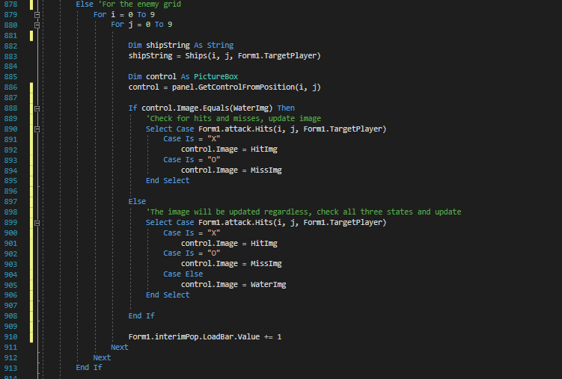

This way the enemy panel which is mostly comprised of water images, does not unnecessarily update itself. Similarly, for the friendly panel and its ships it should update;

* Where there is a ship from the previous player
* Where there is a ship from the current player

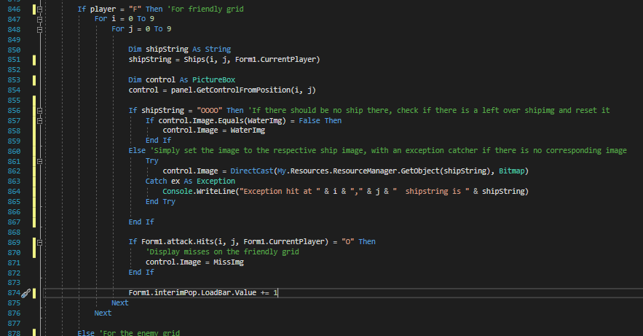

Changing the select cases to involve if then, or if then else structures to implement the above changes increases the efficiency and thus speed of loading between turns:

*Ship Placement*

Ship placement was originally to be placed based upon the selected ship, and selected grid point. Using the selected ship which contains how many tiles, and in what orientation the ship would be placed, first the validity of the ship’s placement would be tested, and then either a message to the user would be sent, or the ship[] array updated. The first conceptual implementation of this is as follows:

Pic

BEGIN PlaceShip(x as integer, y as integer, player as integer)

Get SelectedShip

Declare horizontal as Boolean

If Mid(SelectedShip,2,1) = “H” then

Horizontal = true

Else

Horizontal = false

End If

GetShipLength(SelectedShip)

Declare obstructed as boolean

Obstructed = false

*‘First check for obstructions*

If horizontal then

For i = 1 to ShipLength

Declare localx as integer

Localx = x – 1 + i

If localx < 0 or localx > 9 then

Obstructed = true

Exit For

Else If Ships(localx,y,player) <> “OOOO” then Obstructed = true

Exit For

End If

Next i

Else

For i = 1 to ShipLength

Declare localy as integer

Localy = y – 1 + i

If localy < 0 or localy > 9 then

Obstructed = true

Exit For

Else If Ships(x,localy,player) <> “OOOO” then

Obstructed = true

Exit For

End If

Next i

End If

*‘Then either communicate invalid placement, or place ship*

If obstructed then

Display Message “Invalid placement”

Exit Function

ElseIf horizontal then

For i = 1 to ShipLength

Declare localx as integer

Localx = x – 1 + i

Declare ShipString as string

Shipstring = Left(SelectedShip,1)

ShipString += Mid(Selectedship,2,1) ShipString += i

ShipString += “O”

Ships(localx,y,player) = ShipString

Next i

Else

For i = 1 to ShipLength

Declare localy as integer

Localy = y – 1 + i

Declare ShipString as string

Shipstring = Left(SelectedShip,1)

ShipString += Mid(Selectedship,2,1) ShipString += i

ShipString += “O”

Ships(x,localy,player) = ShipString

Next i

End If

END PlaceShip

However, when adding the feature of picking up placed ships, in addition to checking and changing the conditions of an entire ship for sinking, it was found that they all shared a similar algorithmic approach, thus they were all integrated into a single function ‘ShipFiller’ which has overloaded Booleans to indicate whether to place, remove or sink a ship.

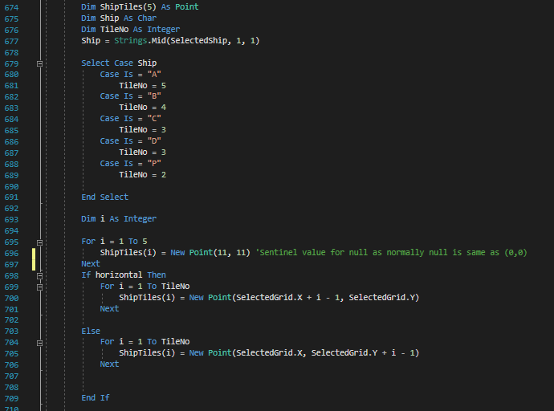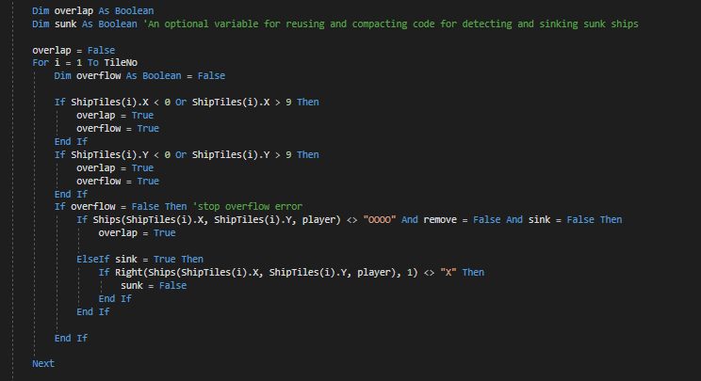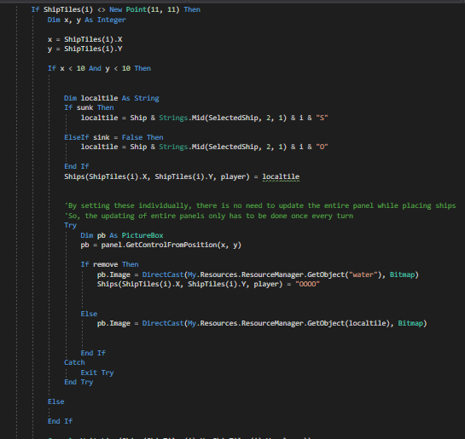

However, during the game, attacks will most likely land on tiles other than the first tile of the ship, meaning that an addition algorithm must be created to fabricate the first tile of the ship, so that it can be passed into the above algorithm.

User Registration Module

BUD Loader

BEGIN Function LoadBUD

Get BUD.Txt from local files

Declare TempUsers(40,2) as string

Declare counter as integer = 0

Readtext = Read next line from BUD.Txt ‘Reads the first line’

DO

TempUsers(counter,0) = Readtext

Readtext = Read next line from BUD.Txt

TempUsers(counter,1) = ReadText

Readtext = Read next line from BUD.Txt ‘Reads the start of the next User’s file to check for null values’

Counter += 1

UNTIL Readtext is null

Re declare the User array’s 1st dimension to be length of counter + 1

‘Updates the public User array, with the exact length so that it is entirely full of Users and won’t have null exceptions’

FOR j = 0 to counter

Users(j,0) = TempUsers(j,0)

Users(j,1) = TempUsers(j,1)

NEXT j

END

For the above algorithm, It was designed to load every user and their password into the public array without any gaps or possibility of null exceptions. This way, the other algorithms which reference the user array do not have to check or have workarounds for null exceptions.

However, for score and other statistics for each individual player, more size in the second dimension are necessary. These statistics and information can be stored in a file specific to each user, for which another algorithm must be written. The IO.streamreader that visual basic uses to read from text files automatically creates a text file for the name it is searching for if it does not exist. This text file would relate to the use of a new ‘User’ structure, which can hold all the user’s details, as well as find it’s own details using the following method:

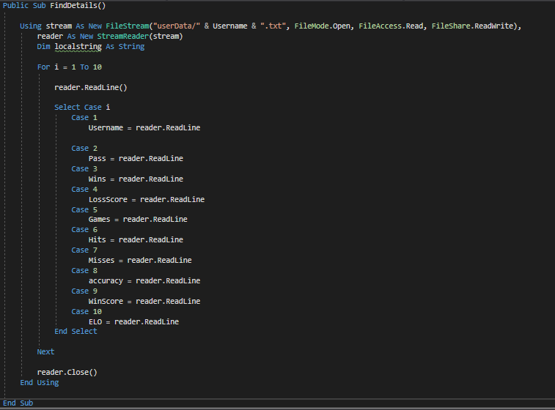

So, the user array was changed to be an array of User structures, which hold further details on users from their specific text files. During this process it was also discovered that the above algorithm both missed the final user or added a null final user depending on the number of users in the BUD, to ensure that no nuances in the DO UNTIL loop caused this, the temporary loading of the BUD was changed to utilise a WHILE loop.

This is implemented in the final code as follows:

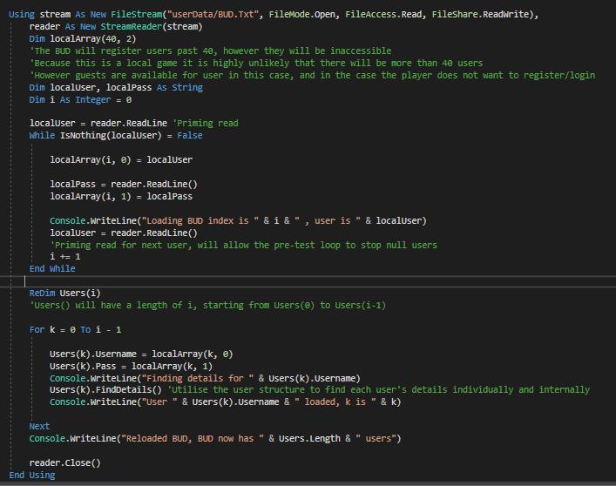

# Screen Designs

Menu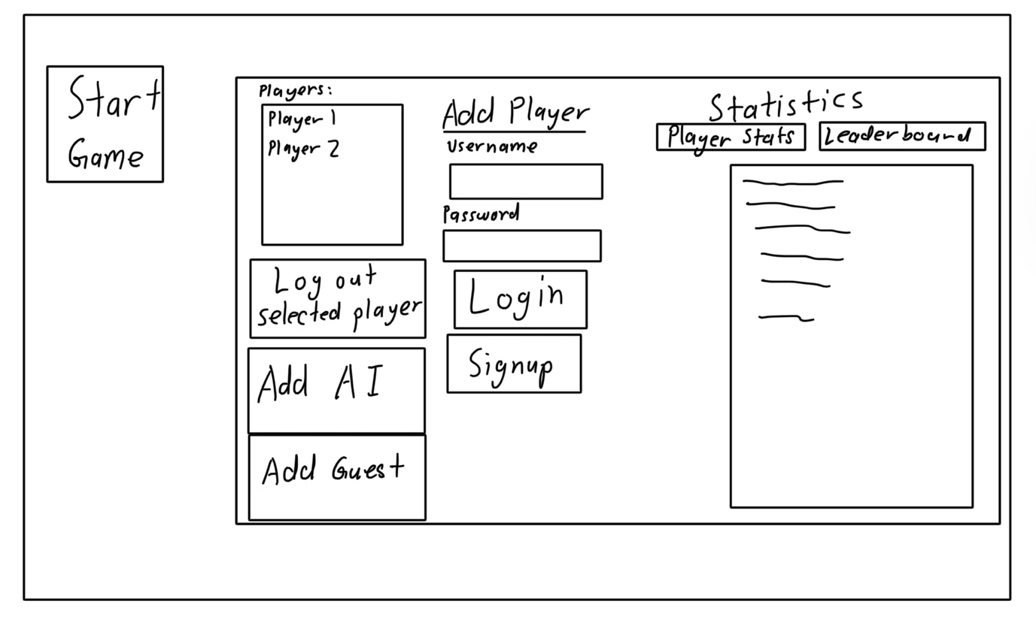

This screen design for the menu encompasses user registration and stat/leaderboard display into one to limit the need for navigation and hence reduce user confusion, however cluttered buttons also impact on user experience.

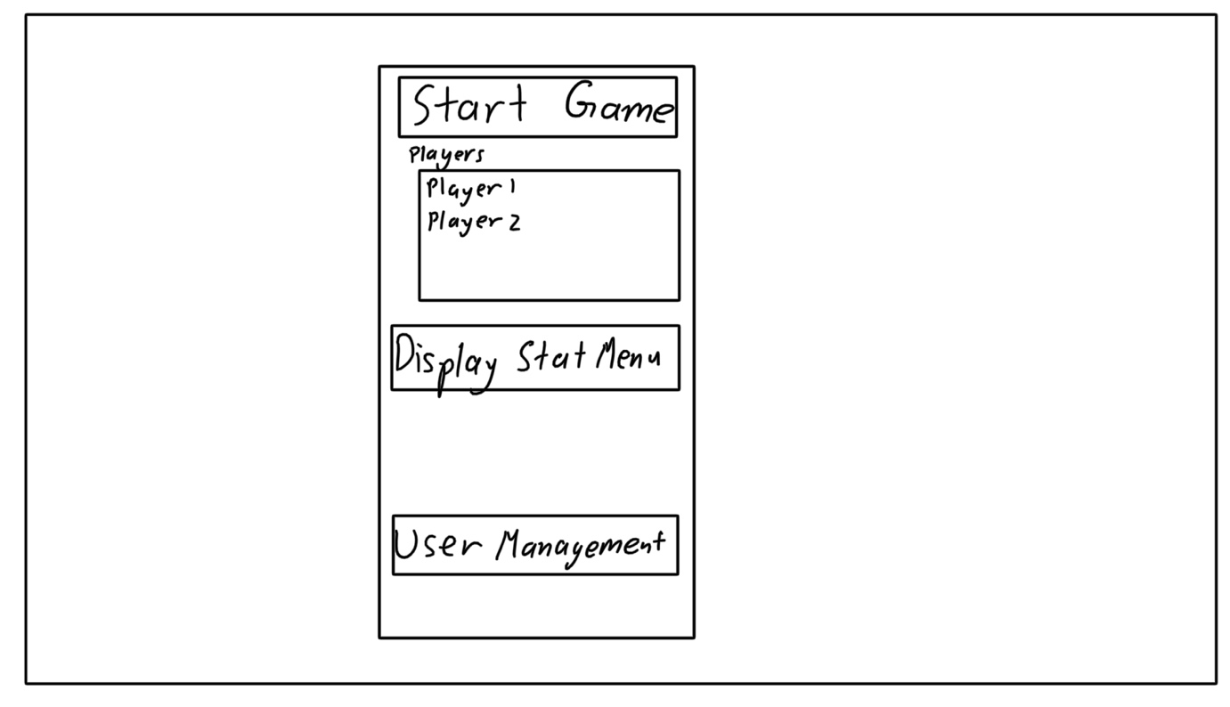

This design is the opposite of the design above, it is a small menu with limited buttons to reduce user confusion and makes clear buttons for navigations with their purpose “User Management” “Display Stat Menu” “Start Game”. This design was employed in the demonstration game below:

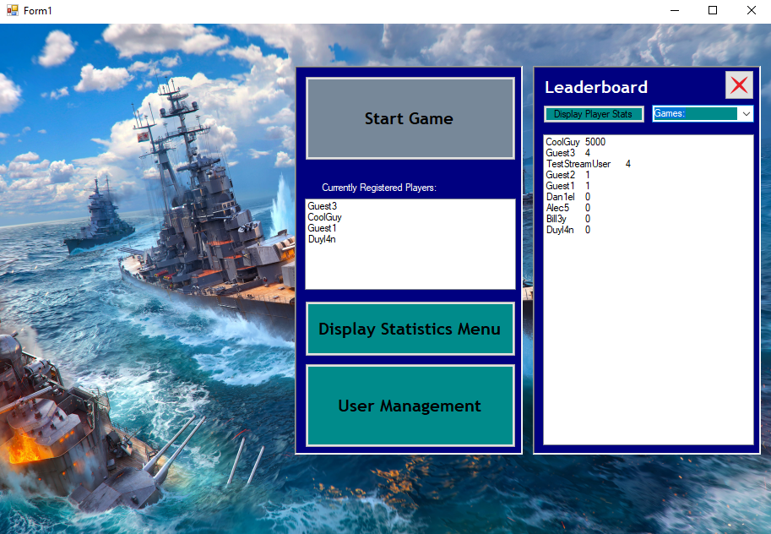

Game



The two above screen designs are the intitial foundations for the two player and four player grid layouts, however, considering how the four player’s panels will change and confuse players between turns it is the four player layout is undesirable.



This screen design was that of the layout phase for the new combination of two player and multi-player game modes, it was discussed previously in the user communication issues, and is much more desirable than the preceding layouts.

The following designs contain options for the layout and attack phase:

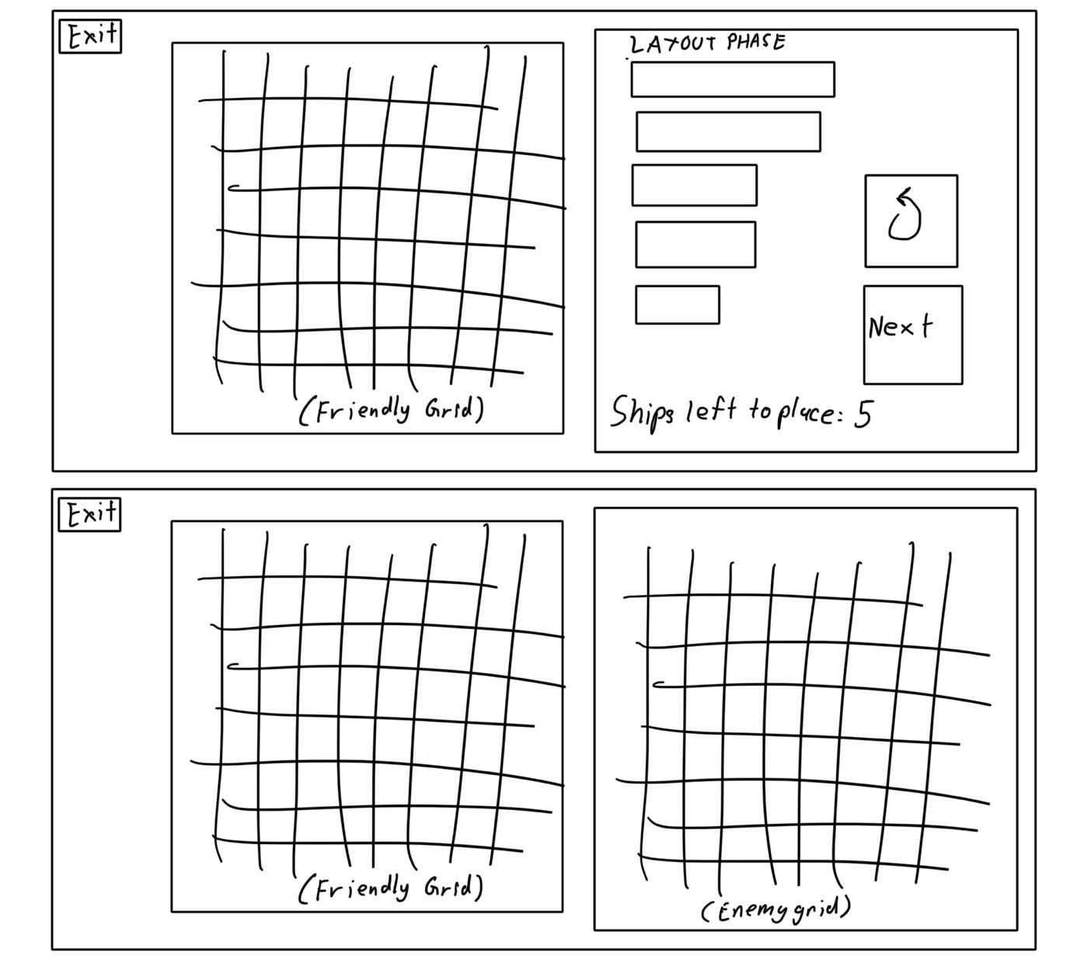





The designs in black were utilised for the demonstration of the game as pictured below:

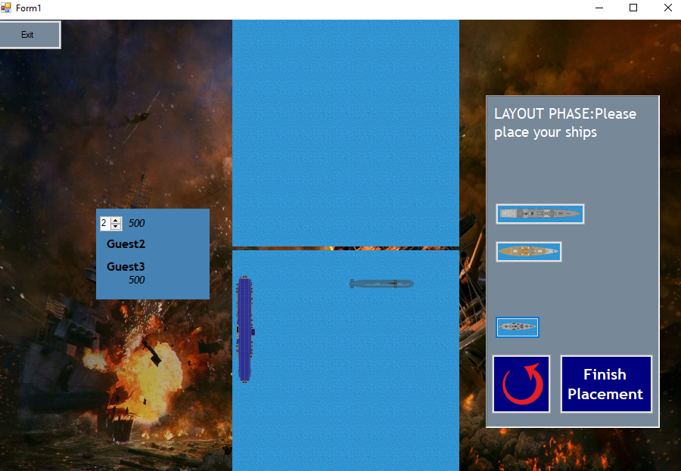

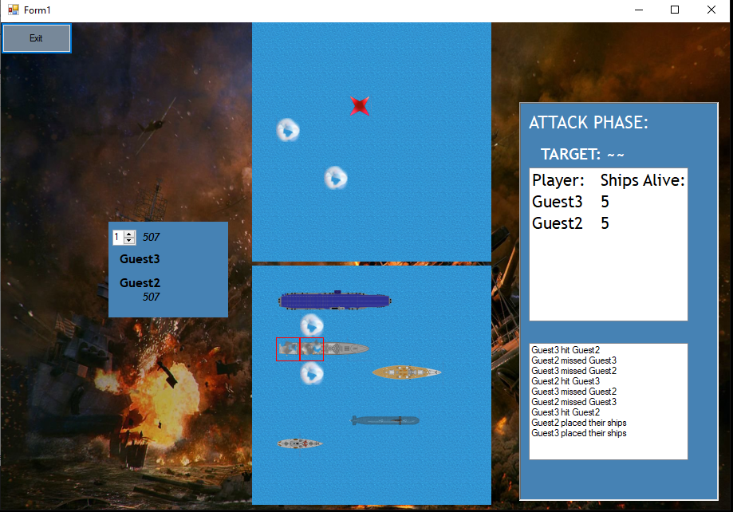

The layout and attack panels display relevant information and controls, with both panels directing the user “Please place your ships” and “Target:”. The ID Panel also contains relevant information on who the current player is (bottom name) and who the targeted player is (top name) respective to the bottom/top panels displayed, in addition to their ELOs and the targeting index.

In the attack phase, it is very necessary for users to understand hits, misses and other events including how many ships players have especially if none, this is done through the history list, and the ships remaining list.

It was discovered during user testing that the custom-made hit and sink images while indicating their states, were not contrasted enough to the other states, hence remaining unclear to users where and what their ships conditions are. The simple red borders on hit tiles displayed above contrasts to the seamless tiling between all other panels to highlight the amount of tiles hit as well as the remaining tiles.

Interim Screen (Including AI Visualisation)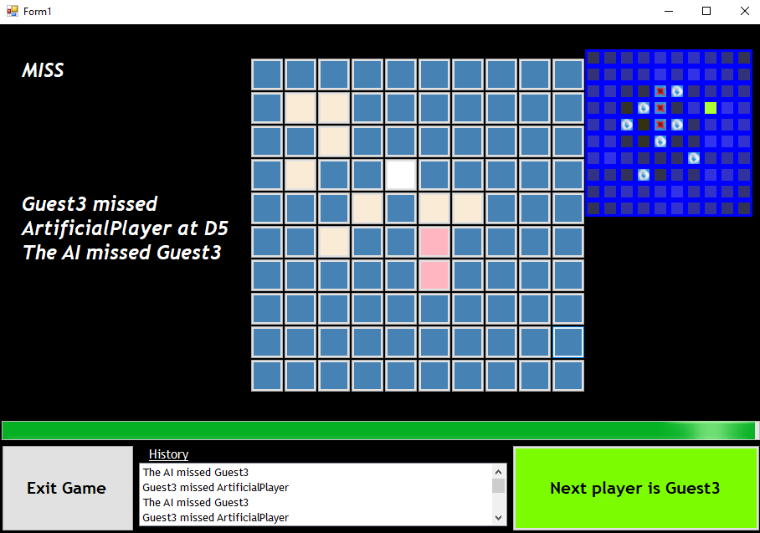

The pale whites and pinks indicate previous hits and misses, while the white/red indicates the latest miss/hit. As outlined in the discussion of communications with the user, this allows for more complicated games with more players, by displaying the latest hit(s) as well as an easily accessible history and short message.

The visualisation of the AI is added mainly for entertainment, but serves as a niche debugging tool, and understanding of the AI’s most recent moves similar to the main hit/miss visualisation.

The loading bar, exit button and next button are all necessary items for this interim screen, allowing players to exit at any times and continue once the load bar and the changing of players is completed.

User Registration

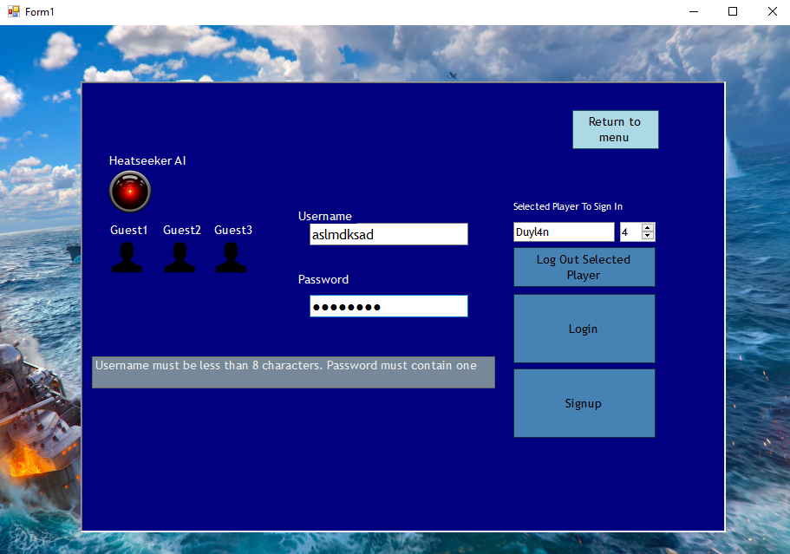

The above layout was both the first conceptualised layout for user registration, however it was also considered that user registration would be integrated with the menu:

**

Both user registrations contain a censored password textbox and username textbox to utilise well-known conventions of logging in, alongside login and signup buttons for their respective functions. The selected player to sign in displays which player is at the current index, to log out and view players that are already logged in.

The standalone user registration has individually the guest 1-3 profiles and AI, which are options for special, password-less log-ins.

The message box displays the requirements for valid usernames and passwords appropriately and dynamically to the user’s input.